
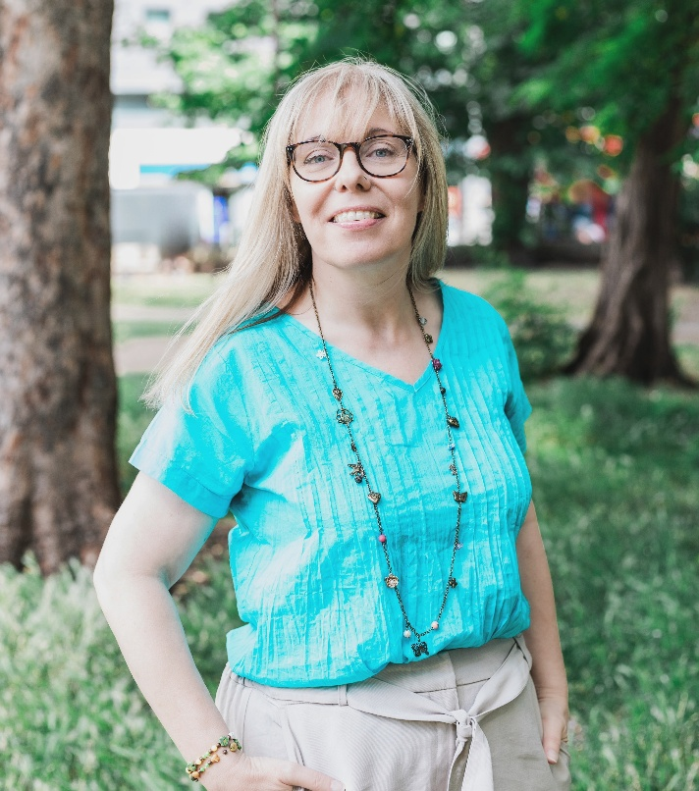

Monday June 15th
at 7pm

An evening with local author Sam Carrington (aka Alice Hunter) at Ipplepen Hub
Sam will talk about her books, and the recent adaptation of The Serial Killer’s Wife into a 4-part TV series. After a break for refreshments (included in the ticket price), she will take questions from the room.
Sam will also bring books to sign if you want to purchase them on the night.
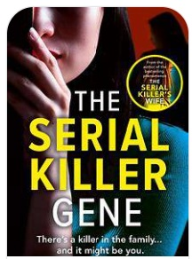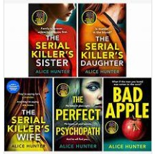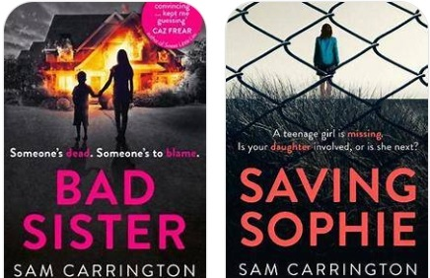

Tickets are £7 in advance, or £8 on the door, to raise funds for the Hub.
Tickets can be purchased in person from the Hub, or by emailing ipplepenhub@gmail.com, and specifying how many you require.
Doors will open at 6.45pm for a 7pm start.
We look forward to seeing you there.

